Bio-Data
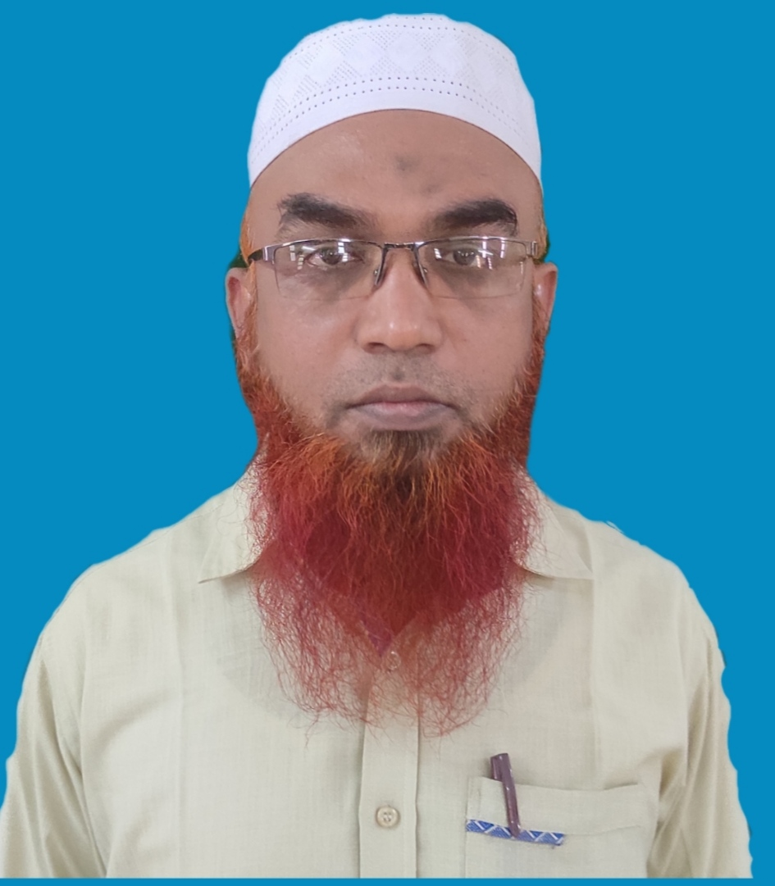

1. Name : M.KAMAL
2. Sex : Male
3. Designation : Assistant Professor &
Member In-Charge
4. Date of Birth : 02-01-1982
5. Address for Communication :
Residence Office
1/SF A1 ARK ROYAL APARTMENT DEPARTMENT OF COMPUTER APPLICATIONS
SAMAD SCHOLL STREET JAMAL MOHAMED COLLEGE
KHAJA NAGAR, TRICHY-620 020 TRICHY-620 020
kamal.jmc@gmail.com
Mobile: 99943 68482

6. Educational Qualification:
Examination Passed year
Ph.D. Pursuing
M.PHIL. (C.S) 2007
M.Sc. (C.S) 2004
7. Experience:
Undergraduate : 18 YEARS
Postgraduate : 18 YEARS
8. Language Known : English, Tamil
9. Area of Specialization : Operating Systems, Java
Programming, Cloud Computing
10. Subjects Taught:
Undergraduate:
1. Java Programming
2. Operating Systems
3. Object Oriented Programming with C++
4. Programming in C
5. Database Management Systems
6. Computer Networks
7. Scripting Language
8. Data Structures and Algorithms

Postgraduate:
1. Advanced Java Programming
2. Operating Systems
3. Compiler Design
4. Computer Networks
5. Web Technology
6. Middleware Technology
11. Research supervision: -
M.Phil. Degree- Thesis Completed -
Thesis Pursuing -
Ph.D. Degree -

12. Seminars / Conferences / Workshops Attended:
i. Participated State Level Workshop on “Research Prospects in Data Mining”, Department of Computer Science, Jamal Mohamed College, and Trichy-20 conducted on 22nd March 2007.

ii. Participated in National Conference on “Frontier Research Areas in Computing Sciences” Bharathidasan University Conducted On 5th and 6th October 2007.

iii. Participated in National Level Work shop on “Digital Image and Video Processing”, Department of Mathematics and Computer Applications, National Institute of Technology, Trichy conducted on 7th , 8th and 9th November 2008.

iv. Participated in National Level Seminar on “IT – Today & Tomorrow” – Pixel Show 2008 organized by the Academy of Computer Science, Muthayammal College of Arts & Science, Rasipuram, Namakkal District conducted on 1st March 2008.

v. Participated in State Level Seminar on “Examination Reforms” organized by Jamal Mohamed College, Trichy-20 conducted on 12th March 2010.

vi. Participated in State Level Seminar on “Creating Competitiveness to excel in higher education – a TQM approach” organized by Internal Quality Assurance Cell, Jamal Mohamed College, Trichy-20 conducted on 8th December 2010.

vii. Participated in National Level Seminar on “ Quality Enhancement in Teaching, Research and Extension in Higher Education Institutions – Prospects and Problems” organized by the Internal Quality Assurance Cell, Jamal Mohamed College, Trichy-20 conducted on 15th and 16th April 2010.

viii. Participated in National Level Seminar on “Teaching, Learning and Research in Higher Education – Excellence and Beyond Excellence” organized by the Internal Quality Assurance Cell, Jamal Mohamed College, Trichy-20 conducted on 7th March 2012.

ix. Participated in Two Day Faculty Development Programme on Soft Skills organized by the Internal Quality Assurance Cell, Jamal Mohamed College, Trichy-20 conducted on 4th and 5th January 2013.

x. Participated in National Conference on Advanced Computing organized by Department of Computer Science, Jamal Mohamed College, Trichy-20 conducted on 7th April 2013.

xi. Participated in Two day workshop on “Android & Its Apps” organized by Department of Computer Science and Applications, Periyar Maniammai University, Vallam, Thanjavur on 13th & 14th September, 2013.

xii. Participated in Two-Day workshop on Research Methodology in Computer Science(WEKA & MATLAB) organized by Department of Computer Science, Jamal Mohamed College, Trichy and Computer Society of India, Trichy on 2nd and 3rd March 2014.

xiii. Participated in National Conference on Advanced Computing organized by Department of Computer Science, Jamal Mohamed College, Trichy-20 conducted on 5th March 2014.

xiv. Participated the Awareness and Demonstration Programme on “Sixth Sense Technologies in U Class rooms” organized by Department of Computer Science, A.V.V.M. Sri Pushpam College, Poondi, Thanjavur on 10th March, 2014.

xv. Participated in National Conference on Advanced Computing organized by Department of Computer Science, Jamal Mohamed College, Trichy-20 conducted on 5th March 2015.

xvi. Participated in Five days Faculty Development Program on “Cloud Infrastructure and Services” conducted by ICT Academy of Tamil Nadu and Kalasalingam University, Krishnan koil on 23rd to 27th February 2015.

xvii. Participated in National Conference on Computing and Communication Technologies organized by Department of Information Technology, Jamal Mohamed College, Trichy-20 conducted on 17th September 2016.

xviii. Participated in One-Day workshop on The Role of a Teacher in the Present Scenario organized by Internal Quality Assurance Cell, Jamal Mohamed College, Trichy on 3rd December 2016.

xix. Participated in National Conference on Advanced Computing organized by Department of Computer Science, Jamal Mohamed College, Trichy-20 conducted on 15th March 2017.

xx. Participated in Three-Day workshop on NLP-Based Faculty Empowerment Programme organized by Internal Quality Assurance Cell, Jamal Mohamed College, Trichy on 17th, 18th and 19th June 2017.

- Participated “National Conference on Advanced Computing” organized by PG & Research Department of Computer Science, Jamal Mohamed College, Trichy on 2017.

- Participated “National Conference on Computing and Communication Technologies” organized by PG & Research Department of Computer Science, Jamal Mohamed College, Trichy on 20th Feb 2018.

- Participated “Professional Development for Academic Leadership in Curriculam Design” organized by Jamal Mohamed College, Trichy on 18th and 19th January 2019.

- Participated “National Conference on Advanced Computing” organized by PG & Research Department of Computer Science, Jamal Mohamed College, Trichy on 12th Mar 2019.

- Participated “Staff Enrichment Programme on Ownership Culture” organized by the Internal Quality Assurance Cell, Jamal Mohamed College, Trichy on 14th June 2019.

- Participated “Emerging Trends in Computer Science” organized by Government College for Women (Autonomous), Kumbakonam, on 13.07.2019 & 14.07.2019

- Participated “International Joint Webinar & PG Colloquium 2020” on 28th December 2020 conducted by Multimedia University, Malyasia, Mahindrea Engineering College and Jamal Mohamed College, Trichy.

13. Paper Presented:
a). Presented paper entitled on “Information and Communication Technologies” in National Level Conference on “Management In the Age of Innovation” at Jamal Institute of Management, Jamal Mohamed College, Trichy-20 on 25th January 2011.

b) Presented paper entitled on “RFID with Supply Chain to Enhance Productivity”, in National Level Conference on “Management in the Age of Innovation” at Jamal Institute of Management, Jamal Mohamed College, and Trichy-20 ion 25th January 2011.

c) Presented paper entitled on “PCM: Power Consumption Method using IOT” in National Level Conference on “Computing and Communicating Technologies” at PG Department of Information Technology, Jamal Mohamed College, Trichy-20 on 20th February 2018.

d) Presented paper entitled on “A Multilayer Data Security using Matrix Transformation and RSA for Public Cloud Storage” at PG & Research Department Computer Science, Information Technology & Computer Applications, Jamal Mohamed College (Autonomous), Trichy on 2nd March 2023.

d) Presented paper entitled on “Data Security using Enhanced RSA in Public Cloud Storage” in A One Day International Conference on New Trends in Computing Technologies at PG & Research Department Computer Science, Sudharsan College of Arts and Science, Pudukkottai 17th March 2023

14. Publications:
a) Information and Communication Technologies pp.610-612 Published in the Journal of Jamal Institute of Management, Jamal Mohamed College, Trichy-20.

b) RFID with Supply Chain to Enhance Productivity, pp. 592-594 published in the Journal of Jamal Institute of Management, Jamal Mohamed College, and Trichy-20.

c) PCM: Power Consumption Method using IOT” published in International Journal of Emerging Technology & Advance Engineering, February 2018.

d) A Survey on Data Security in Cloud Computing using Cryptography Algorithms, International Journal of Innovations in Engineering and Technology, (IJIET), http://dx.doi.org/10.21172/ijiet.161.01

e) Enhancing Data Security in Public Cloud Storage using Obfuscation Techniques, International Journal of Advanced Science and Technology, Vol. 29, No.4, (2020), pp.7784 – 7796 (Scopus Index)

f) Secured Private Key Generation Using RSA For Data Security In Public Cloud Storage, Webology (ISSN: 1735-188X), Volume 18, Number 6, 2021, 7668 http://www.webology.org (Scopus Indexed)

g) Magnifying the Key Stability of RSA Algorithm in Data Security for Public Cloud, IJCSNS International Journal of Computer Science and Network Security, VOL.22 No.6, June 2022, https://doi.org/10.22937/IJCSNS.2022.22.6.10 (Web of Science)

15. Seminars / Conferences/ Workshops Organized:
a) Organized a National Conference on Computing and Communication Technology (NCCCT – 2016) at Department of Information Technology, Jamal Mohamed College (Autonomous), Tiruchirappalli held on 25th February 2017.

b) Organized a National Conference on Computing and Communication Technology (NCCCT – 2017) at Department of Information Technology, Jamal Mohamed College (Autonomous), Tiruchirappalli held on 20th February 2018.

b) Organized a National Conference on Advanced Computing (NCAC – 2023) at pg & Research Department of Computer Science, Information Technology and Computer Applications, Jamal Mohamed College (Autonomous), Tiruchirappalli held on 2nd March 2023

16. Membership in Academic Bodies: JMC – Board of Studies

17. Membership in Professional Bodies: NIL

18. Participation in Consultancy, Training and Development etc.:
- Received the certificate of Digital Skills Readiness Program Wipro Certify Faculty, conducted by Wipro Talent Next, Wipro campus, Bangalore, on 29-10.2021.

19. Participation in Extracurricular Activities:
a) Athletic b) Volley ball c) Ball Badminton

20. Administrative Positions held in college:
From 2015, Time Table In-Charge, Jamal Mohamed College, Trichy-20.

21. Membership in Autonomous Programme:
- Member of Board of Studies in Computer Science in Jamal Mohamed College (Autonomous), Tiruchirappalli, 620 020

22. Orientation / Refresher Courses Attended:
- Participated and Completed the Course of Cloud Infrastructure and Services – Level 1 conducted by EMC2 Academic Associates on 27th February, 2015.
- Participated the Wipro Certified Faculty Program organized by Talent Next, Wipro, Bangalore dated from 14-09-2020 to 30-09-2020

23. Study Materials / Books Written and Published:
Study Material for BCA Course – Java Programming

24. Resource Person:
- Acted as a Judge for the event “Web Development Programme” organized by Jamal Mohamed College for B.Ed. Education March 2015.
- Acted as a Judge for “Internal Hackathon for Smart India Hackathon 2020” conducted by Jamal Mohamed College, Trichy on 13th January 2020.
- Acted as a Resource Person delivered the topic on “Software Project Development” organized by Holy Cross College, Trichy on 07.01.2021
- Acted as a Resource Person delivered the topic on “MySQL Database Connectivity” workshop organized by Holy Cross College, Trichy on 04.03.2021

- Acted as a Judge for Business Quiz in Comex, Inter-Collegiate Technical Symposium organized by PG and Research Department of Commerce, Jamal Mohamed College, Trichy on 02.03.2023
M m25. Any other information:
- Vice-President of Computer Application Association on 2009-2010
- Vice-President of Computer Application Association on 2017-2018
- Treasurer of JMC Baithulmal Society from 2019-2021

